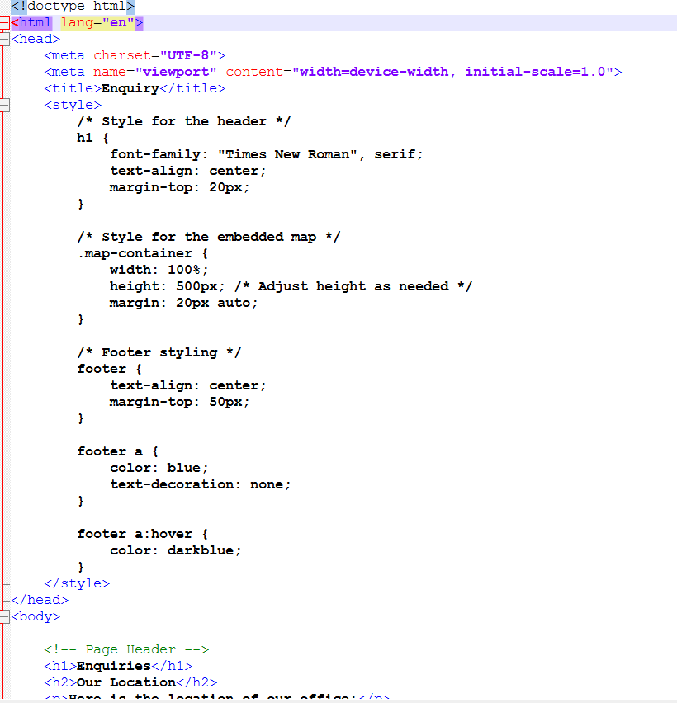

Adding internal css to style the displayed embedded maps
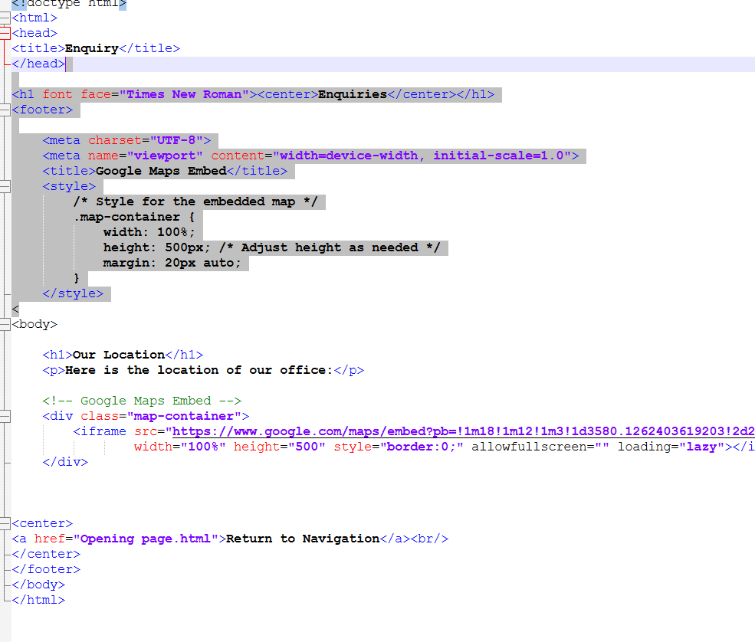
Google maps embedded showing the location under the enquiries tab of rosebank college as the mai headquarters of the Writer’s bureau center
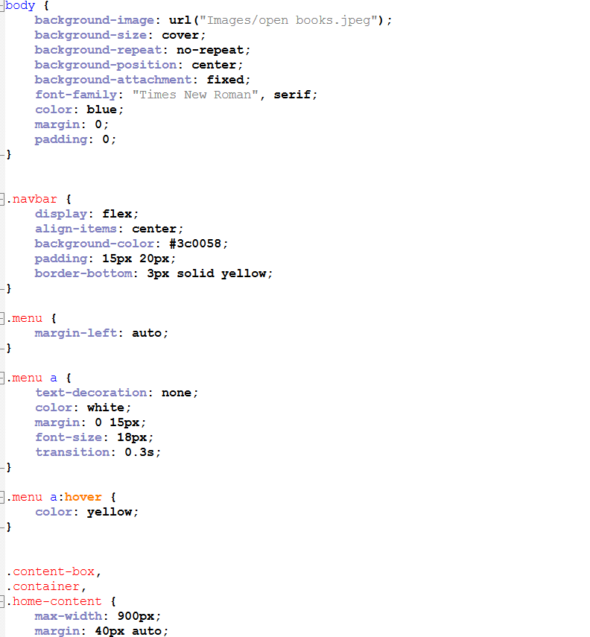

External css used to improve styling and structure
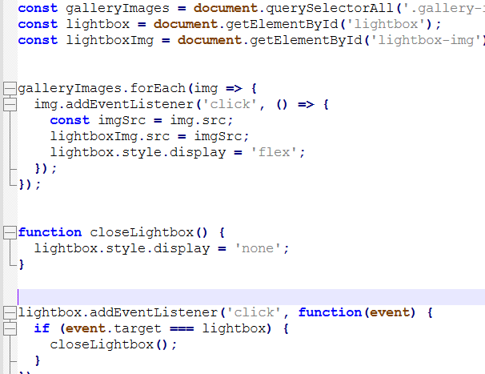
External java used to improve functionality and interactiveness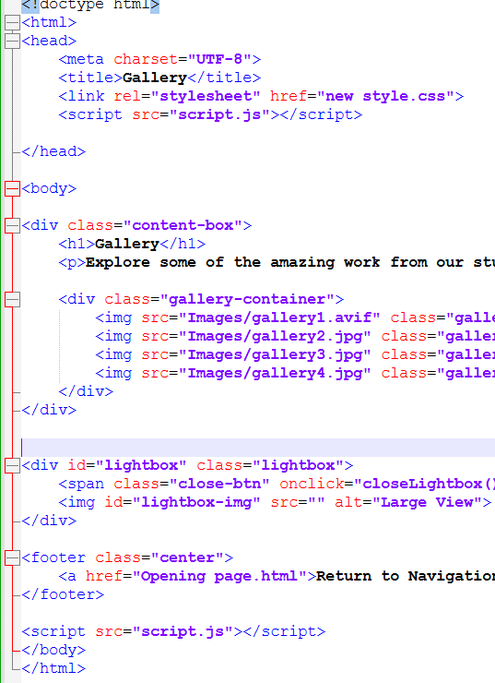

Lightbox added to improve the styling and functionality of images in gallery
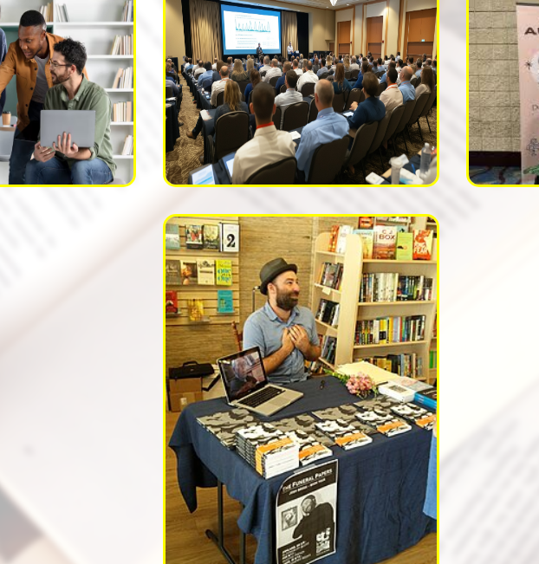
Functional gallery tab on website
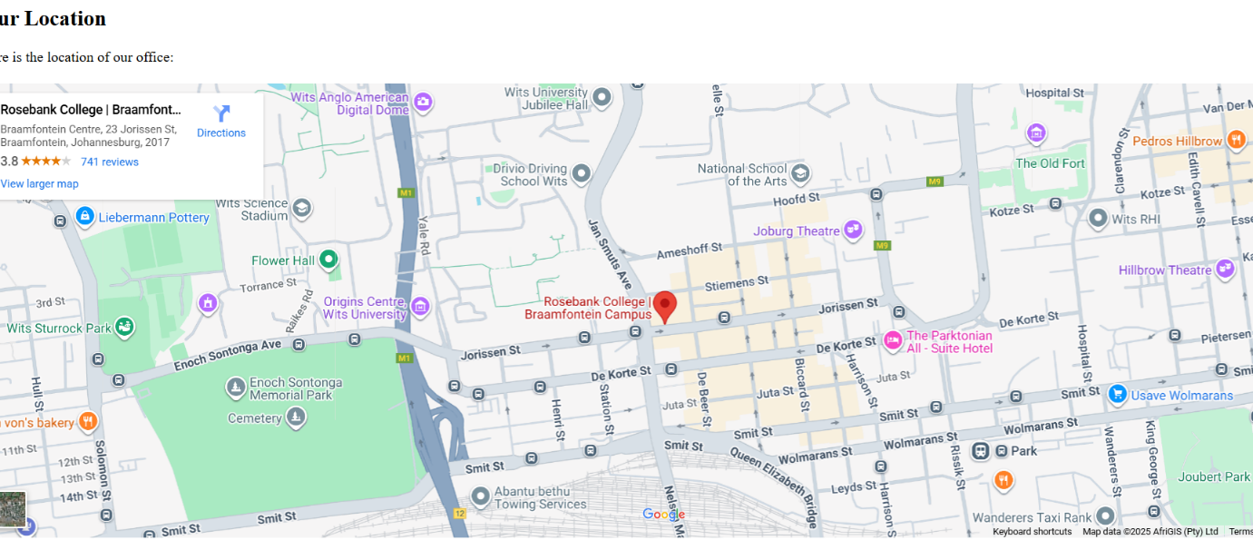

Functional and interactive embedded google maps

